VOCABULARY- China/India

Daoism

Mudra

Ushnisha

Stupa
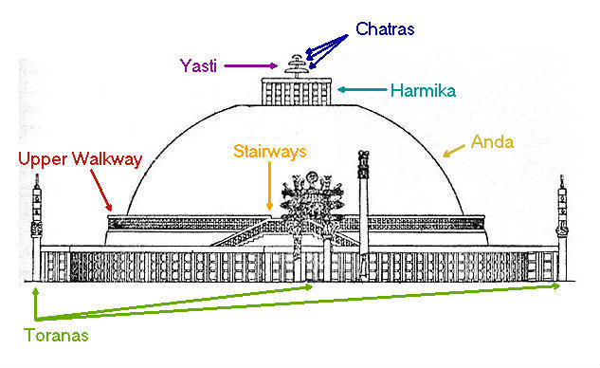

Chatras

Yasti

Harmika

Torana

Yakshi

Circumambulation

Ashoka

Bronze Casting

Three Perefctions

Pagoda

CHINESE HOUSE CONSTRUCTION
Eaves

Purlins

Rafters

CHINESE DYNASTIES (This is advice!)
List the Dynasties and connect with the artwork from “the 250”

Shiva

Miniature Paintings

Handscroll

Porcelain

Mughal Empire

Hindu Temple

vimana

Sikhara

